**The Elite English School Dubai**

**Computer Science Project 2020-2021**

LifeSaver

A program that can save a soul

**By Team:**

**Siri Chandana Pallapu – 12A**

**Augusta Christy- 12A**

**DayaSivasriSivakumar- 12A**

**Teacher:**

**Supriya Sharma**

CERTIFICATE

This is to certify that the **Computer Project** titled

**LifeSaver Emergency Program**

Has been successfully completed by

**Siri Chandana Pallapu**

Of class XII in partial fulfillment of curriculum of Central Board of Secondary Education (CBSE) leading to the award of annual examination of the

Year 2020-21.

Sign: Sign:

Internal Examiner External Examiner

ACKNOWLEDGEMENT

I would like to express my deepest appreciation to all those who provided me the possibility to complete this report. A special gratitude I give to our **Computer Science Teacher Mrs. Supriya Sharma** whose contribution in stimulating suggestions and encouragement, helped me to coordinate my project especially in writing this report. I would like to extend my sincere thanks to the management of Elite English School.

Sign:

Name:

***Front End***

Our program helps patients to contact or book on appointment in registered hospitals faster, especially in emergency cases. The code can be used to create offline application too.

When somebody has to book an appointment in a hospital, our program takes in details from the user such as the details required for registration and shows the user the nearest hospitals in which they can go. It also asks if they patient needs ambulance and reports it to hospital, which they hospital can take care of.

***Back End***

Code

**Our program has a code of total elevenfiles**.

**File 1:**

import tkinter as tk

root = tk.Tk()

v = tk.IntVar()

v.set(0)

from openpyxl import *

from tkinter import *

defone():

import Part2.py

exec(Part2.py)

deftwo():

import Part2a.py

exec(Part2a.py)

defthree():

import Part2b.py

exec(Part2b.py)

deffour():

import Part2c.py

exec(Part2c.py)

tk.Label(root,

text="""Choose an OPTION""",

justify = tk.LEFT,

padx = 20).pack()

tk.Radiobutton(root,

text="Emergency",

indicatoron = 0,

width = 20,

padx = 20,

variable=v,

command= one,

).pack(anchor=tk.W)

tk.Radiobutton(root,

text="Non-emergency",

indicatoron = 0,

width = 20,

padx = 20,

variable=v,

command= two,

).pack(anchor=tk.W)

tk.Radiobutton(root,

text="Covid-19",

indicatoron = 0,

width = 20,

padx = 20,

variable=v,

command= three,

).pack(anchor=tk.W)

tk.Radiobutton(root,

text="Other",

indicatoron = 0,

width = 20,

padx = 20,

variable=v,

command= four,

).pack(anchor=tk.W)

root.mainloop()

**File 2:**

import tkinter as tk

from tkinter import ttk

root = tk.Tk()

v = tk.IntVar()

v.set(0) # initializing the choice, i.e. Python

tk.Label(root,

text="""Choose the Problem""",

justify = tk.LEFT,

padx = 20).pack()

from openpyxl import *

from tkinter import *

wb = load_workbook('C:\\Users\\USER\\Desktop\\lifesaver database.xlsx')

sheet = wb.active

defexcel():

sheet.column_dimensions['E'].width = 30

sheet.cell(row=1, column=6).value = "Problem"

excel()

current_row = sheet.max_row

current_column = sheet.max_column

sheet.cell(row=current_row +1 , column=5).value = "Emergency"

defoneone():

current_row = sheet.max_row

current_column = sheet.max_column

sheet.cell(row=current_row, column=6).value = "Heart Attack"

wb.save('C:\\Users\\USER\\Desktop\\lifesaver database.xlsx')

deftwotwo():

current_row = sheet.max_row

current_column = sheet.max_column

sheet.cell(row=current_row, column=6).value = "Brain complication"

wb.save('C:\\Users\\USER\\Desktop\\lifesaver database.xlsx')

defthreethree():

current_row = sheet.max_row

current_column = sheet.max_column

sheet.cell(row=current_row, column=6).value = "Accident"

wb.save('C:\\Users\\USER\\Desktop\\lifesaver database.xlsx')

deffourfour():

current_row = sheet.max_row

current_column = sheet.max_column

sheet.cell(row=current_row, column=6).value = "Other"

wb.save('C:\\Users\\USER\\Desktop\\lifesaver database.xlsx')

tk.Radiobutton(root,

text="Heart attack",

indicatoron = 0,

width = 20,

padx = 20,

variable=v,

command= oneone,

).pack(anchor=tk.W)

tk.Radiobutton(root,

text="Brain complication",

indicatoron = 0,

width = 20,

padx = 20,

variable=v,

command= twotwo,

).pack(anchor=tk.W)

tk.Radiobutton(root,

text="Accident",

indicatoron = 0,

width = 20,

padx = 20,

variable=v,

command= threethree,

).pack(anchor=tk.W)

tk.Radiobutton(root,

text="Other",

indicatoron = 0,

width = 20,

padx = 20,

variable=v,

command= fourfour,

).pack(anchor=tk.W)

deflocation():

import webbrowser

webbrowser.open("maps.html")

show = tk.Button(root, text="see locations of hospitals", fg="Black",

bg="Red", command= location)

show.pack()

defch_hos():

import chosehospital.py

exec(chosehospital.py)

choose= tk.Button(root, text="choose hospital", fg="Black",

bg="Red", command= ch_hos)

choose.pack()

root.mainloop()

**File 2 Subparts:**

**File 2a:**

import tkinter as tk

from tkinter import ttk

root = tk.Tk()

v = tk.IntVar()

v.set(0) # initializing the choice, i.e. Python

tk.Label(root,

text="""Choose the Problem""",

justify = tk.LEFT,

padx = 20).pack()

from openpyxl import *

from tkinter import *

wb = load_workbook('C:\\Users\\USER\\Desktop\\lifesaver database.xlsx')

sheet = wb.active

defexcel():

sheet.column_dimensions['H'].width = 30

sheet.cell(row=1, column=6).value = "Problem"

excel()

current_row = sheet.max_row

current_column = sheet.max_column

sheet.cell(row=current_row +1, column=5).value = "Nonemergency"

defoneone():

current_row = sheet.max_row

current_column = sheet.max_column

sheet.cell(row=current_row , column=6).value = "Dental"

wb.save('C:\\Users\\USER\\Desktop\\lifesaver database.xlsx')

deftwotwo():

current_row = sheet.max_row

current_column = sheet.max_column

sheet.cell(row=current_row, column=6).value = "Check-up"

wb.save('C:\\Users\\USER\\Desktop\\lifesaver database.xlsx')

defthreethree():

current_row = sheet.max_row

current_column = sheet.max_column

sheet.cell(row=current_row, column=6).value = "Other"

wb.save('C:\\Users\\USER\\Desktop\\lifesaver database.xlsx')

tk.Radiobutton(root,

text="Dental",

indicatoron = 0,

width = 20,

padx = 20,

variable=v,

command= oneone,

).pack(anchor=tk.W)

tk.Radiobutton(root,

text="Check up",

indicatoron = 0,

width = 20,

padx = 20,

variable=v,

command= twotwo,

).pack(anchor=tk.W)

tk.Radiobutton(root,

text="Other",

indicatoron = 0,

width = 20,

padx = 20,

variable=v,

command= threethree,

).pack(anchor=tk.W)

deflocation():

import webbrowser

webbrowser.open("maps.html")

show = tk.Button(root, text="see locations of hospitals", fg="Black",

bg="Red", command= location)

show.pack()

defch_hos():

import chosehospital.py

exec(chosehospital.py)

choose= tk.Button(root, text="choose hospital", fg="Black",

bg="Red", command= ch_hos)

choose.pack()

root.mainloop()

**Part 2b:**

import tkinter as tk

from tkinter import ttk

root = tk.Tk()

v = tk.IntVar()

v.set(0) # initializing the choice, i.e. Python

tk.Label(root,

text="""Choose the Problem""",

justify = tk.LEFT,

padx = 20).pack()

from openpyxl import *

from tkinter import *

wb = load_workbook('C:\\Users\\USER\\Desktop\\lifesaver database.xlsx')

sheet = wb.active

defexcel():

sheet.column_dimensions['H'].width = 30

sheet.cell(row=1, column=6).value = "Problem"

excel()

current_row = sheet.max_row

current_column = sheet.max_column

sheet.cell(row=current_row + 1, column=5).value = "Covid19"

defoneone():

current_row = sheet.max_row

current_column = sheet.max_column

sheet.cell(row=current_row, column=6).value = "Complication"

wb.save('C:\\Users\\USER\\Desktop\\lifesaver database.xlsx')

deftwotwo():

current_row = sheet.max_row

current_column = sheet.max_column

sheet.cell(row=current_row, column=6).value = "Checkup"

wb.save('C:\\Users\\USER\\Desktop\\lifesaver database.xlsx')

defthreethree():

current_row = sheet.max_row

current_column = sheet.max_column

sheet.cell(row=current_row, column=6).value = "Other"

wb.save('C:\\Users\\USER\\Desktop\\lifesaver database.xlsx')

tk.Radiobutton(root,

text="Complication",

indicatoron = 0,

width = 20,

padx = 20,

variable=v,

command= oneone,

).pack(anchor=tk.W)

tk.Radiobutton(root,

text="Checkup",

indicatoron = 0,

width = 20,

padx = 20,

variable=v,

command= twotwo,

).pack(anchor=tk.W)

tk.Radiobutton(root,

text="Other",

indicatoron = 0,

width = 20,

padx = 20,

variable=v,

command= threethree,

).pack(anchor=tk.W)

deflocation():

import webbrowser

webbrowser.open("maps.html")

show = tk.Button(root, text="see locations of hospitals", fg="Black",

bg="Red", command= location)

show.pack()

defch_hos():

import chosehospital.py

exec(chosehospital.py)

choose= tk.Button(root, text="choose hospital", fg="Black",

bg="Red", command= ch_hos)

choose.pack()

root.mainloop()

**Part 2c:**

import tkinter as tk

from tkinter import ttk

root = tk.Tk()

v = tk.IntVar()

v.set(0) # initializing the choice, i.e. Python

tk.Label(root,

text="""Choose the Problem""",

justify = tk.LEFT,

padx = 20).pack()

from openpyxl import *

from tkinter import *

wb = load_workbook('C:\\Users\\USER\\Desktop\\lifesaver database.xlsx')

sheet = wb.active

defexcel():

sheet.column_dimensions['H'].width = 30

sheet.cell(row=1, column=6).value = "Problem"

excel()

current_row = sheet.max_row

current_column = sheet.max_column

sheet.cell(row=current_row + 1, column=5).value = "other"

defoneone():

current_row = sheet.max_row

current_column = sheet.max_column

sheet.cell(row=current_row, column=6).value = "Special case"

wb.save('C:\\Users\\USER\\Desktop\\lifesaver database.xlsx')

deftwotwo():

current_row = sheet.max_row

current_column = sheet.max_column

sheet.cell(row=current_row, column=6).value = "Check up"

wb.save('C:\\Users\\USER\\Desktop\\lifesaver database.xlsx')

defthreethree():

current_row = sheet.max_row

current_column = sheet.max_column

sheet.cell(row=current_row, column=6).value = "Other"

wb.save('C:\\Users\\USER\\Desktop\\lifesaver database.xlsx')

tk.Radiobutton(root,

text="Special case",

indicatoron = 0,

width = 20,

padx = 20,

variable=v,

command= oneone,

).pack(anchor=tk.W)

tk.Radiobutton(root,

text="Check up",

indicatoron = 0,

width = 20,

padx = 20,

variable=v,

command= twotwo,

).pack(anchor=tk.W)

tk.Radiobutton(root,

text="Other",

indicatoron = 0,

width = 20,

padx = 20,

variable=v,

command= threethree,

).pack(anchor=tk.W)

deflocation():

import webbrowser

webbrowser.open("maps.html")

show = tk.Button(root, text="see locations of hospitals", fg="Black",

bg="Red", command= location)

show.pack()

defch_hos():

import chosehospital.py

exec(chosehospital.py)

choose= tk.Button(root, text="choose hospital", fg="Black",

bg="Red", command= ch_hos)

choose.pack()

root.mainloop()

**File 3:**

import tkinter as tk

root = tk.Tk()

v = tk.IntVar()

v.set(0) # initializing the choice, i.e. Python

tk.Label(root,

text="""Choose the Hospital""",

justify = tk.LEFT,

padx = 20).pack()

from openpyxl import *

from tkinter import *

wb = load_workbook('C:\\Users\\USER\\Desktop\\lifesaver database.xlsx')

sheet = wb.active

defexcel():

sheet.column_dimensions['H'].width = 30

sheet.cell(row=1, column=8).value = "Hospital Chosen"

excel()

def savehospital1():

hello= "hospital 1"

current_row = sheet.max_row

current_column = sheet.max_column

sheet.cell(row=current_row, column=8).value = hello

wb.save('C:\\Users\\USER\\Desktop\\lifesaver database.xlsx')

def savehospital2():

hello= "hospital 2"

current_row = sheet.max_row

current_column = sheet.max_column

sheet.cell(row=current_row, column=8).value = hello

wb.save('C:\\Users\\USER\\Desktop\\lifesaver database.xlsx')

def savehospital3():

hello= "hospital 3"

current_row = sheet.max_row

current_column = sheet.max_column

sheet.cell(row=current_row, column=8).value = hello

wb.save('C:\\Users\\USER\\Desktop\\lifesaver database.xlsx')

tk.Radiobutton(root,

text="Hospital 1",

indicatoron = 0,

width = 20,

padx = 20,

variable=v,

command= savehospital1,

).pack(anchor=tk.W)

tk.Radiobutton(root,

text="Hospital 2",

indicatoron = 0,

width = 20,

padx = 20,

variable=v,

command= savehospital2,

).pack(anchor=tk.W)

tk.Radiobutton(root,

text="Hospital 3",

indicatoron = 0,

width = 20,

padx = 20,

variable=v,

command= savehospital3,

).pack(anchor=tk.W)

defformm():

import form.py

exec("C:\\Users\\USER\\Desktop\\siri\\computer_project_completed_files\\form.py")

nexxt = Button(root, text="Next", fg="Black",

bg="Red", command= formm)

nexxt.pack()

root.mainloop()

**File 4:**

from openpyxl import *

from tkinter import *

wb = load_workbook('C:\\Users\\USER\\Desktop\\lifesaver database.xlsx')

sheet = wb.active

defexcel():

sheet.column_dimensions['A'].width = 30

sheet.column_dimensions['B'].width = 10

sheet.column_dimensions['C'].width = 10

sheet.column_dimensions['D'].width = 20

sheet.cell(row=1, column=1).value = "Name"

sheet.cell(row=1, column=2).value = "Contact Number"

sheet.cell(row=1, column=3).value = "Email ID"

sheet.cell(row=1, column=4).value = "Address"

def focus1(event):

contact_no_field.focus_set()

def focus2(event):

email_id_field.focus_set()

def focus3(event):

address_field.focus_set()

defclear():

name_field.delete(0, END)

contact_no_field.delete(0, END)

email_id_field.delete(0, END)

address_field.delete(0, END)

definsert():

if (name_field.get() == "" and

contact_no_field.get() == "" and

email_id_field.get() == "" and

address_field.get() == ""):

print("empty input")

else:

current_row = sheet.max_row

current_column = sheet.max_column

sheet.cell(row=current_row, column=1).value = name_field.get()

sheet.cell(row=current_row, column=2).value = contact_no_field.get()

sheet.cell(row=current_row, column=3).value = email_id_field.get()

sheet.cell(row=current_row, column=4).value =address_field.get()

wb.save('C:\\Users\\USER\\Desktop\\lifesaver database.xlsx')

name_field.focus_set()

clear()

defambulance():

import ambulance.py

exec(ambulance.py)

if __name__ == "__main__":

root = Tk()

root.configure(background='light green')

root.title("lifesaver form")

root.geometry("500x300")

excel()

heading = Label(root, text="Form", bg="light green")

name = Label(root, text="Name", bg="light green")

contact_no = Label(root, text="Contact No.", bg="light green")

email_id = Label(root, text="Email id", bg="light green")

address = Label(root, text="Address", bg="light green")

heading.grid(row=0, column=1)

name.grid(row=1, column=0)

contact_no.grid(row=2, column=0)

email_id.grid(row=3, column=0)

address.grid(row=4, column=0)

name_field = Entry(root)

contact_no_field = Entry(root)

email_id_field = Entry(root)

address_field = Entry(root)

name_field.bind("<Return>", focus1)

contact_no_field.bind("<Return>", focus2)

email_id_field.bind("<Return>", focus3)

name_field.grid(row=1, column=1, ipadx="100")

contact_no_field.grid(row=2, column=1, ipadx="100")

email_id_field.grid(row=3, column=1, ipadx="100")

address_field.grid(row=4, column=1, ipadx="100")

excel()

submit = Button(root, text="Submit", fg="Black",

bg="Red", command= insert)

submit.grid(row=5, column=1)

nexxt = Button(root, text="Next", fg="Black",

bg="Red", command= ambulance)

nexxt.grid(row=6, column=1)

root.mainloop()

**File 5:**

from tkinter import *

class Example(Frame):

def __init__(self):

super().__init__()

self.initUI()

definitUI(self):

self.master.title("Booked")

self.pack(fill=BOTH, expand=1)

canvas = Canvas(self)

canvas.create_text(20, 30, anchor=W, font="Purisa",

text=" Your appointment is successfully booked! ")

canvas.create_text(20, 60, anchor=W, font="Purisa",

text=" Thankyou for using Lifesaver app")

canvas.create_text(20, 130, anchor=W, font="Purisa",

text="__________SUCCESSFUL_________")

canvas.create_text(20, 160, anchor=W, font="Purisa",

text="")

canvas.create_text(20, 190, anchor=W, font="Purisa",

text="Please send your feedback to")

canvas.create_text(20, 220, anchor=W, font="Purisa",

text="lifesaver2020@gmail.com")

canvas.create_text(20, 240, anchor=W, font="Purisa",

text= "https://forms.gle/5TcxSX1AzTNDw1ff7")

canvas.pack(fill=BOTH, expand=1)

defmain():

root = Tk()

ex = Example()

root.geometry("420x250+300+300")

root.mainloop()

if __name__ == '__main__':

main()

from openpyxl import *

from tkinter import *

wb = load_workbook('C:\\Users\\USER\\Desktop\\lifesaver database.xlsx')

sheet = wb.active

hos= sheet.cell(row= 1, column=8).value

defhello():

if hos== "hospital 1":

import mysql_conection.py

exec("C:\\Users\\USER\\Desktop\\siri\\computer_project_completed_files\\mysql_connection.py")

elif hos== "hospital 2":

import mysqlconnectiona.py

exec("C:\\Users\\USER\\Desktop\\siri\\computer_project_completed_files\\mysqlconnectiona.py")

elif hos== "hospital 3":

import mysqlconnectionb.py

exec("C:\\Users\\USER\\Desktop\\siri\\computer_project_completed_files\\mysqlconnectionb.py")

hello()

**File 6:**

import mysql.connector

mydb= mysql.connector.connect(host= 'localhost', database= 'server1', user= 'root', password='siri')

mycursor = mydb.cursor()

from openpyxl import *

from tkinter import *

wb = load_workbook('C:\\Users\\USER\\Desktop\\lifesaver database.xlsx')

sheet = wb.active

oneone= sheet.cell(row=sheet.max_row, column=1).value

twotwo= sheet.cell(row=sheet.max_row, column=2).value

three= sheet.cell(row=sheet.max_row, column=3).value

four= sheet.cell(row=sheet.max_row, column=4).value

five= sheet.cell(row=sheet.max_row, column=5).value

six= sheet.cell(row=sheet.max_row, column=6).value

seven= sheet.cell(row=sheet.max_row, column=7).value

hos= sheet.cell(row= sheet.max_row, column=8).value

case= sheet.cell(row=sheet.max_row , column=5).value

if hos== "hospital 1" and case=="Emergency":

sql = "INSERT INTO emergency (Name, contactno, emailid, address, casetype, casename, ambulanceneeded) VALUES (%s, %s, %s, %s, %s, %s, %s)"

val = (oneone, twotwo, three, four, five, six, seven)

mycursor.execute(sql, val)

elif hos== "hospital 1" and case=="Nonemergency":

sql = "INSERT INTO nonemergency (Name, contactno, emailid, address, casetype, casename, ambulanceneeded) VALUES (%s, %s, %s, %s, %s, %s, %s)"

val = (oneone, twotwo, three, four, five, six, seven)

mycursor.execute(sql, val)

elif hos== "hospital 1" and case=="Covid19":

sql = "INSERT INTO covid19 (Name, contactno, emailid, address, casetype, casename, ambulanceneeded) VALUES (%s, %s, %s, %s, %s, %s, %s)"

val = (oneone, twotwo, three, four, five, six, seven)

mycursor.execute(sql, val)

elif hos== "hospital 1" and case=="other" :

sql = "INSERT INTO other(Name, contactno, emailid, address, casetype, casename, ambulanceneeded) VALUES (%s, %s, %s, %s, %s, %s, %s)"

val = (oneone, twotwo, three, four, five, six, seven)

mycursor.execute(sql, val)

mydb.commit()

print(mycursor.rowcount, "record inserted.")

**File 7:**

import mysql.connector

mydb= mysql.connector.connect(host= 'localhost', database= 'server2', user= 'root', password='siri')

mycursor = mydb.cursor()

from openpyxl import *

from tkinter import *

wb = load_workbook('C:\\Users\\USER\\Desktop\\lifesaver database.xlsx')

sheet = wb.active

oneone= sheet.cell(row=sheet.max_row, column=1).value

twotwo= sheet.cell(row=sheet.max_row, column=2).value

three= sheet.cell(row=sheet.max_row, column=3).value

four= sheet.cell(row=sheet.max_row, column=4).value

five= sheet.cell(row=sheet.max_row, column=5).value

six= sheet.cell(row=sheet.max_row, column=6).value

seven= sheet.cell(row=sheet.max_row, column=7).value

hos= sheet.cell(row= sheet.max_row, column=8).value

case= sheet.cell(row=sheet.max_row , column=5).value

if hos== "hospital 2" and case=="Emergency":

sql = "INSERT INTO emergency (Name, contactno, emailid, address, casetype, casename, ambulanceneeded) VALUES (%s, %s, %s, %s, %s, %s, %s)"

val = (oneone, twotwo, three, four, five, six, seven)

mycursor.execute(sql, val)

elif hos== "hospital 2" and case=="Nonemergency":

sql = "INSERT INTO nonemergency (Name, contactno, emailid, address, casetype, casename, ambulanceneeded) VALUES (%s, %s, %s, %s, %s, %s, %s)"

val = (oneone, twotwo, three, four, five, six, seven)

mycursor.execute(sql, val)

elif hos== "hospital 2" and case=="Covid19":

sql = "INSERT INTO covid19 (Name, contactno, emailid, address, casetype, casename, ambulanceneeded) VALUES (%s, %s, %s, %s, %s, %s, %s)"

val = (oneone, twotwo, three, four, five, six, seven)

mycursor.execute(sql, val)

elif hos== "hospital 2" and case=="other" :

sql = "INSERT INTO other(Name, contactno, emailid, address, casetype, casename, ambulanceneeded) VALUES (%s, %s, %s, %s, %s, %s, %s)"

val = (oneone, twotwo, three, four, five, six, seven)

mycursor.execute(sql, val)

mydb.commit()

print(mycursor.rowcount, "record inserted.")

**File 8:**

import mysql.connector

mydb= mysql.connector.connect(host= 'localhost', database= 'server3', user= 'root', password='siri')

mycursor = mydb.cursor()

from openpyxl import *

from tkinter import *

wb = load_workbook('C:\\Users\\USER\\Desktop\\lifesaver database.xlsx')

sheet = wb.active

oneone= sheet.cell(row=sheet.max_row, column=1).value

twotwo= sheet.cell(row=sheet.max_row, column=2).value

three= sheet.cell(row=sheet.max_row, column=3).value

four= sheet.cell(row=sheet.max_row, column=4).value

five= sheet.cell(row=sheet.max_row, column=5).value

six= sheet.cell(row=sheet.max_row, column=6).value

seven= sheet.cell(row=sheet.max_row, column=7).value

hos= sheet.cell(row= sheet.max_row, column=8).value

case= sheet.cell(row=sheet.max_row , column=5).value

if hos== "hospital 3" and case=="Emergency":

sql = "INSERT INTO emergency (Name, contactno, emailid, address, casetype, casename, ambulanceneeded) VALUES (%s, %s, %s, %s, %s, %s, %s)"

val = (oneone, twotwo, three, four, five, six, seven)

mycursor.execute(sql, val)

elif hos== "hospital 3" and case=="Nonemergency":

sql = "INSERT INTO nonemergency (Name, contactno, emailid, address, casetype, casename, ambulanceneeded) VALUES (%s, %s, %s, %s, %s, %s, %s)"

val = (oneone, twotwo, three, four, five, six, seven)

mycursor.execute(sql, val)

elif hos== "hospital 3" and case=="Covid19":

sql = "INSERT INTO covid19 (Name, contactno, emailid, address, casetype, casename, ambulanceneeded) VALUES (%s, %s, %s, %s, %s, %s, %s)"

val = (oneone, twotwo, three, four, five, six, seven)

mycursor.execute(sql, val)

elif hos== "hospital 3" and case=="other" :

sql = "INSERT INTO other(Name, contactno, emailid, address, casetype, casename, ambulanceneeded) VALUES (%s, %s, %s, %s, %s, %s, %s)"

val = (oneone, twotwo, three, four, five, six, seven)

mycursor.execute(sql, val)

mydb.commit()

print(mycursor.rowcount, "record inserted.")

***Execution:***

**Order of Execution:**

**Execution:**

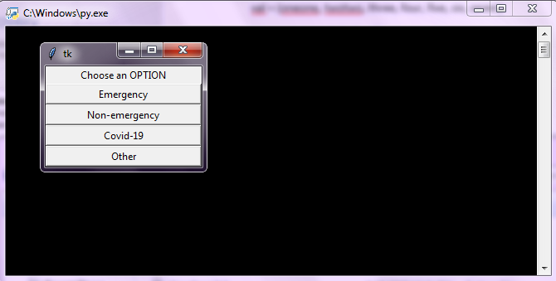

**If we choose Emergency:**

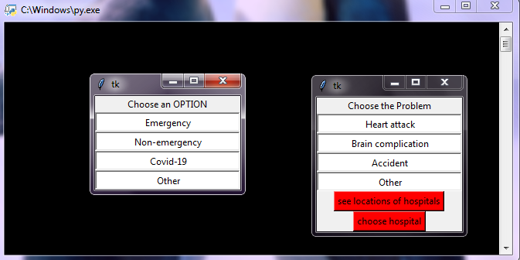

**If we choose Non-emergency:**

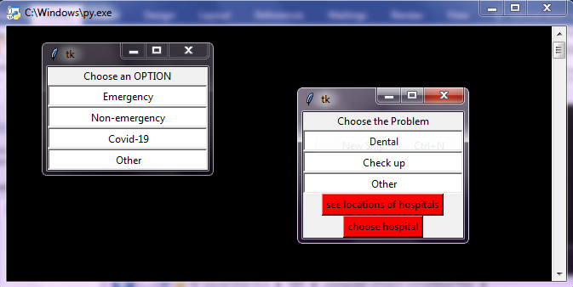

**If we choose Covid-19:**

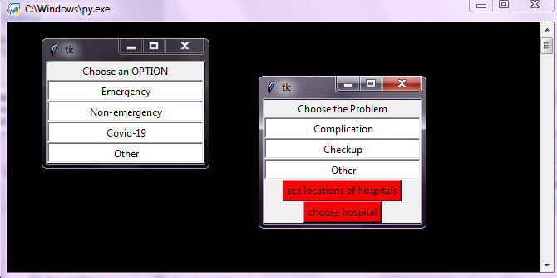

**If we choose Other:**

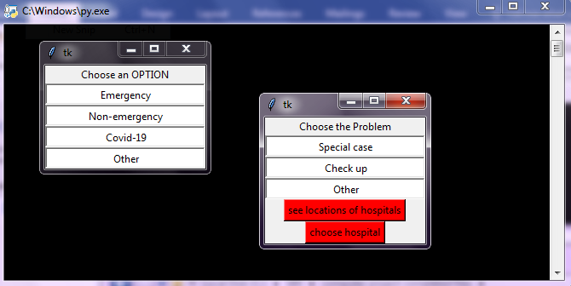**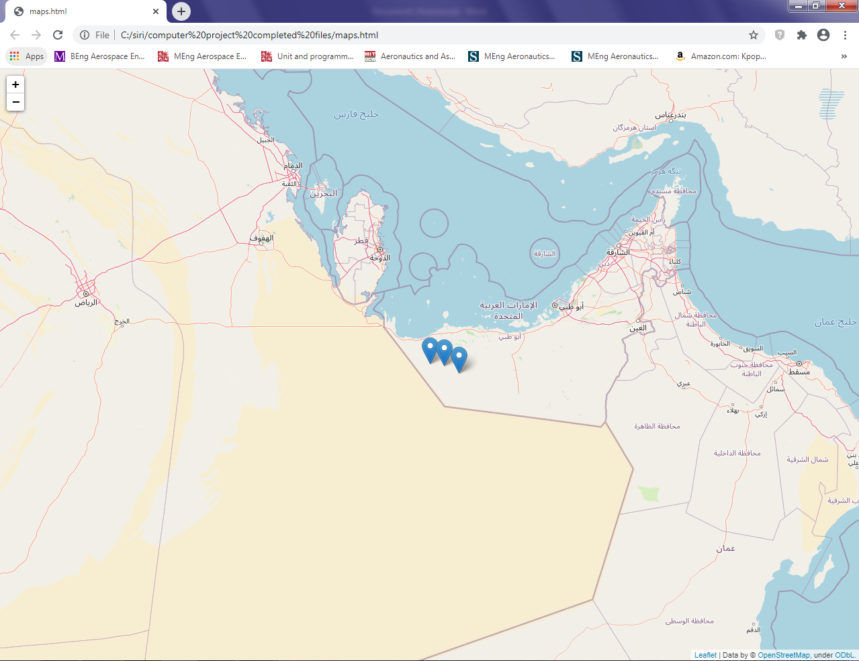In any case, if you chose “see locations of hospitals”:**

**User can choose hospital near to their location as per their wish.**

**As more hospitals register to reach patients this way, more locations can be added to the server as per the hospital’s latitude and longitude.**

**Again, if we choose “choose hospital”:**

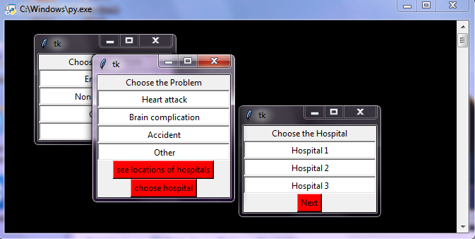

**When we click next:**

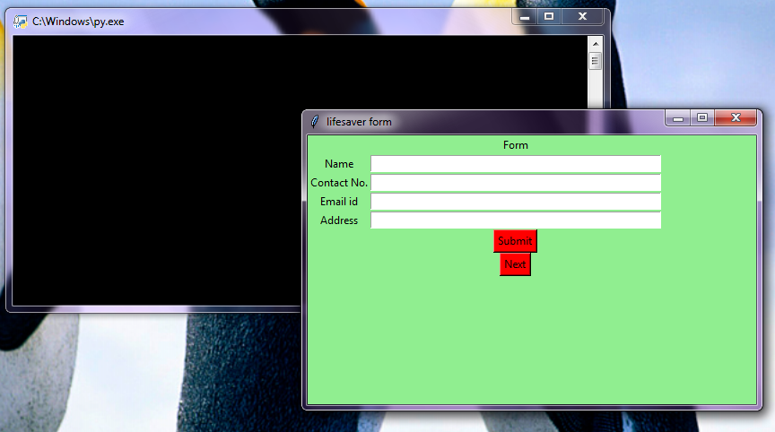

**If we click next, we get:**

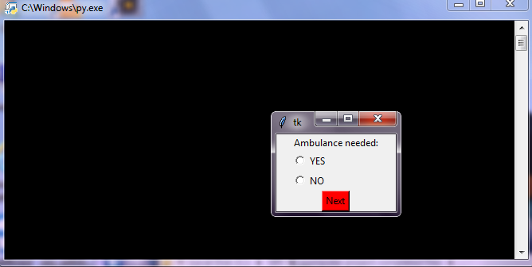

**After clicking next again, we get:**

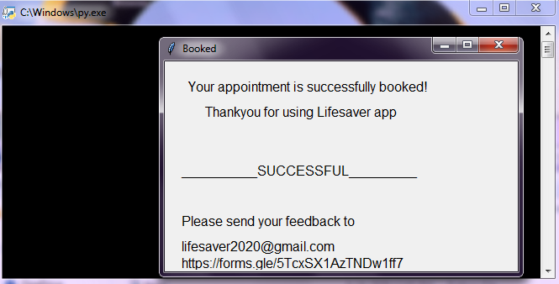

***Sample Execution***

**For instance, if a patient has a heart attack then:**

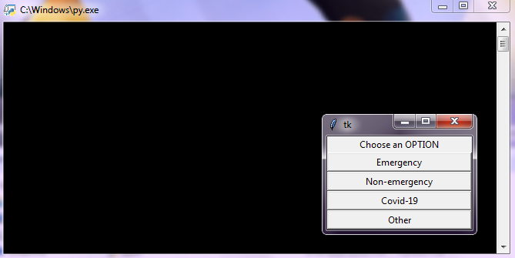

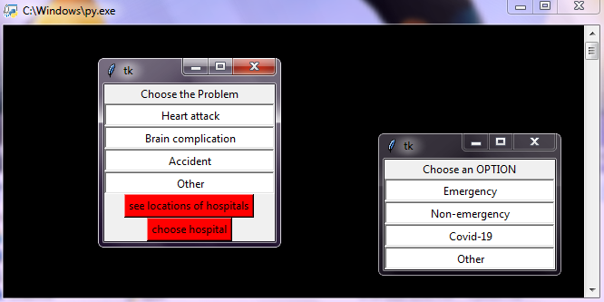

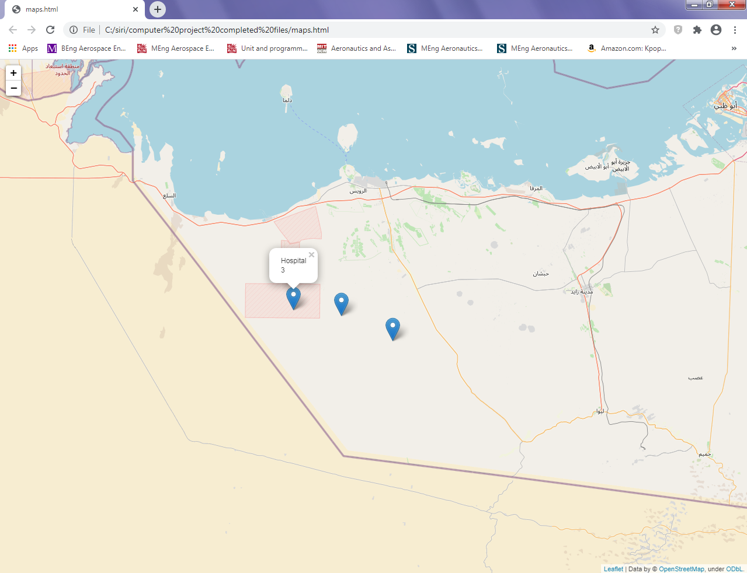**Hospital name will be shown as we click on the location.**

**For instance, if hospital 3 is near and we would want to choose that, then we would click on choose hospital after decision.**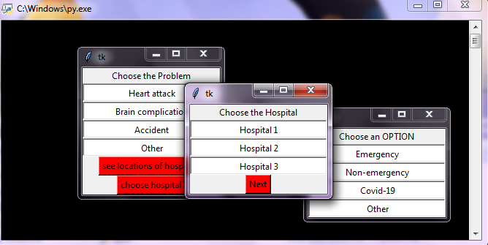

**After clicking next, we get**

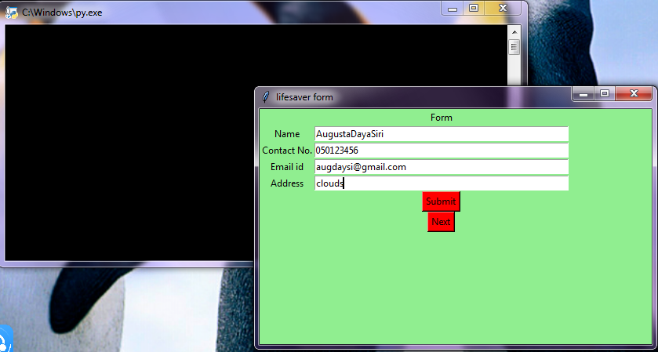

**Click Submit and then Next.**

**We get:**

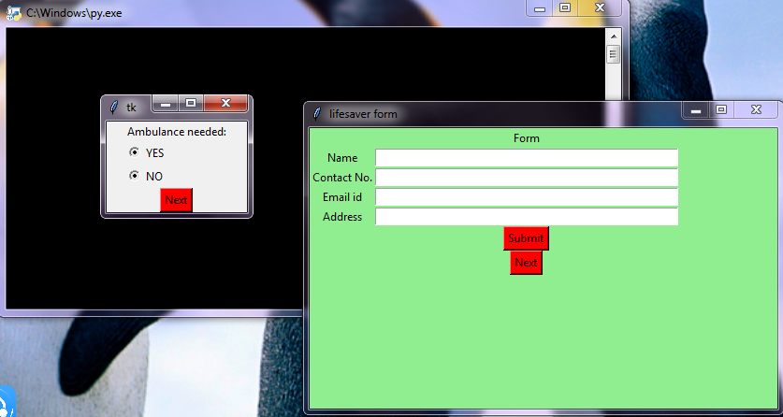

**Let us choose “YES” in ambulance.**

**After clicking “Next” again, we get:**

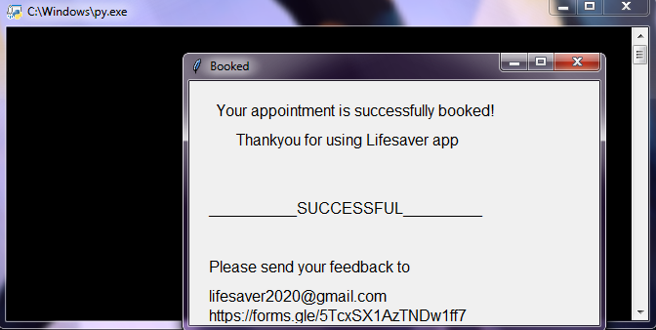

**In the backend, the details first go to an excel form which will be stored by us. This code is then sent to the hospital servers. As an example of code transferring to hospital servers, we have created dummy hospital servers in SQL.**

**The excel form:**

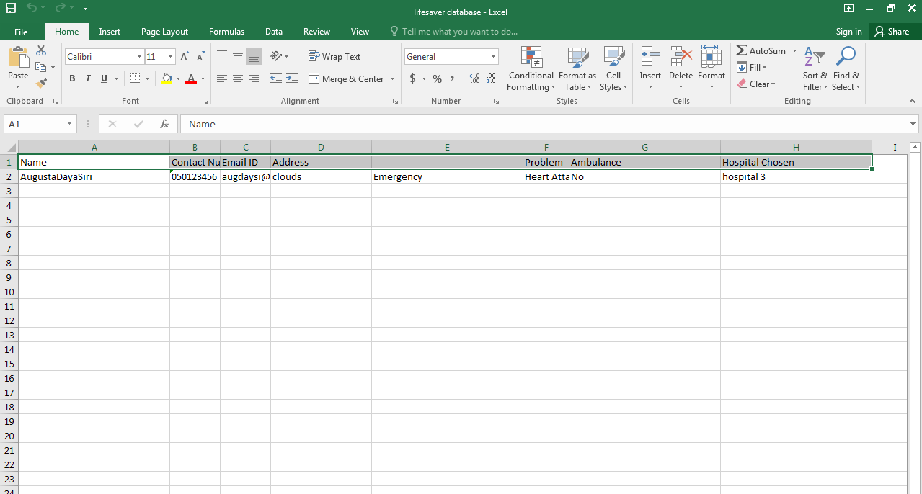

**SQL transferred files (due to execution of file 8 in file 5)**

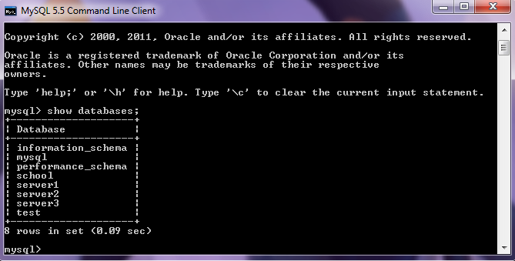

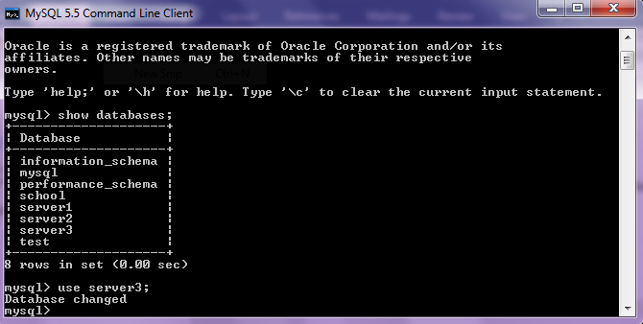

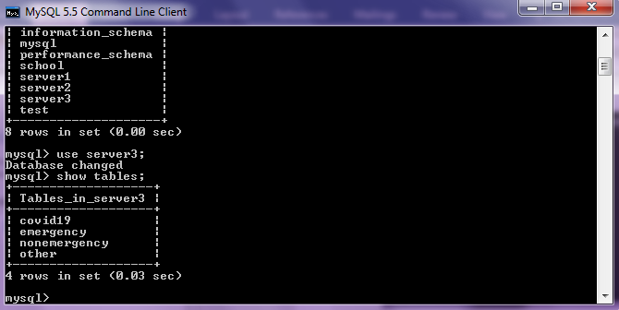

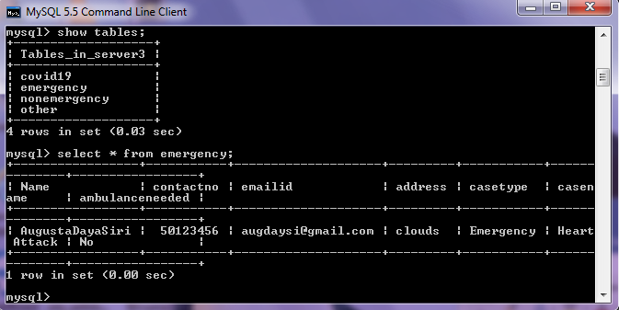

**Hence, the hospital’s server received the patient’s information.**

**Thank You**

**By**

**Siri Chandana Pallapu**

**Of 12-A(Computer Science)**